
DELHI PUBLIC SCHOOL, HAPUR
Session 2025 – 26
Mathemania Competition
Class - II
RESULT DECLARATION

Name of thestudent | Section | Winner |  | Position
Takshi Dhillon | A | 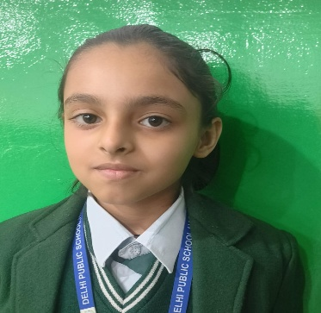 |  | First
Yuvraj Kaushik | A | 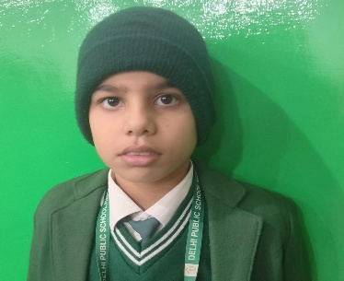 |  | First
Anubhav Tyagi | A | 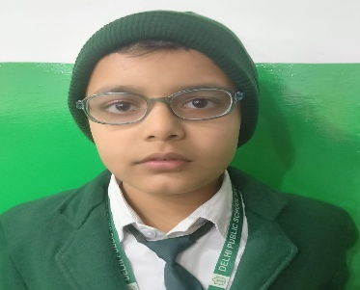 |  | First
Vihaan Karanwal | A | 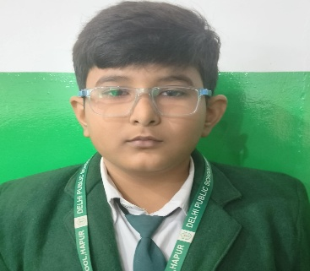 |  | First
Vrati Singhal | C | 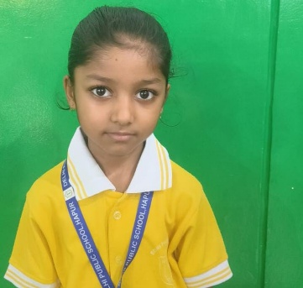 |  | Second
Lakshay Pratap  Singh | C | 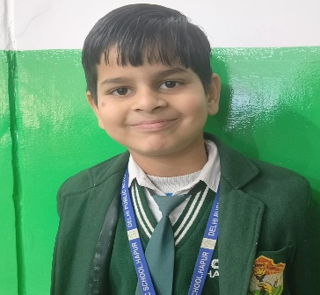 |  | Second
Sharab | C | 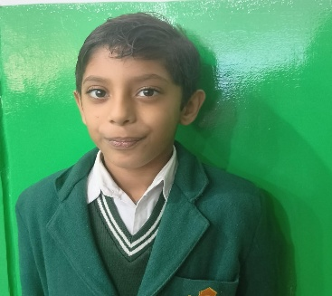 |  | Second
Om Kaushik | C | 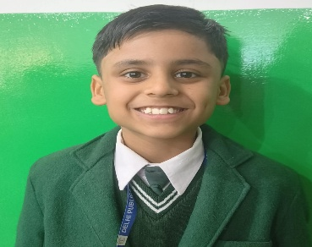 |  | Second
Vidhan Aggarwal | B | 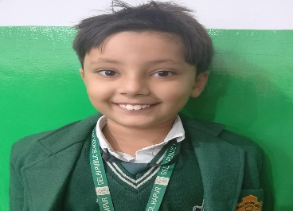 |  | Third
Anay Goel | B | 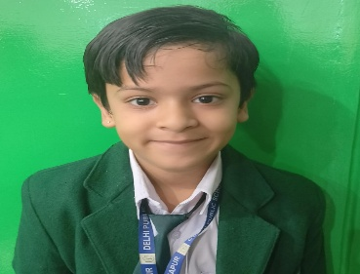 |  | Third
Jinisha Singhal | B | 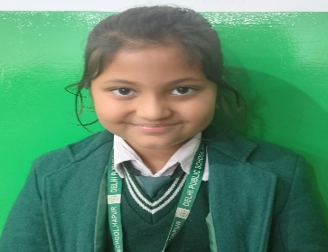 |  | Third
Vikhyat Sharma | B | 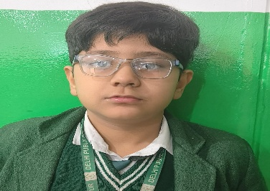 |  | Third

